Data Use Acceleration & Learning (DUAL)
Social Media Kit
October 2022

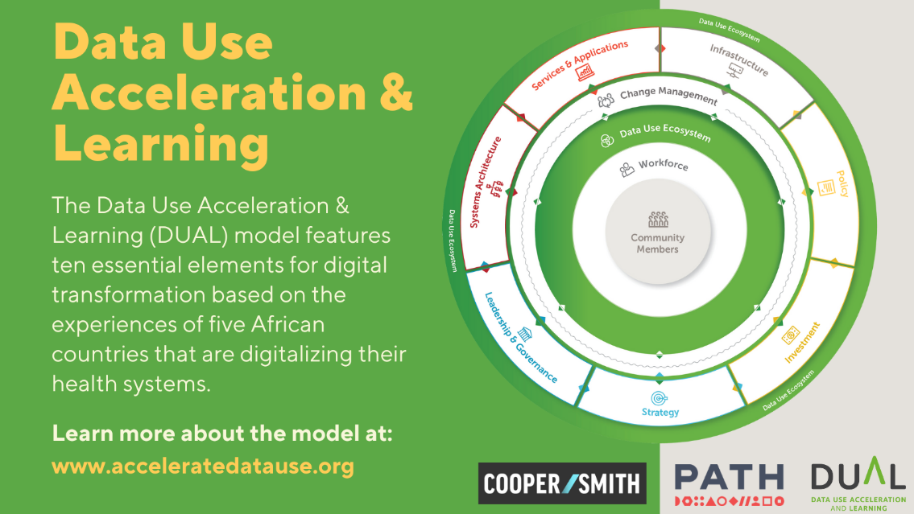

Suggested Twitter Posts
- 🆕New report from @PATHtweets & @CooperSmithOrg shares what works to accelerate health data use & improve health outcomes. The DUAL model & recommendations can be used by governments, implementers & funders to strengthen the uptake of digital technologies: https://www.acceleratedatause.org/
- Many countries are working to digitalize their health care systems & improve health data use. But the lessons learned often are not shared. A new report from @PATHtweets & @CooperSmithOrg documents what works to accelerate digital transformation➡️https://www.acceleratedatause.org/
- Governments in #BurkinaFaso, #Ethiopia, #Malawi, #SouthAfrica & #Tanzania are digitalizing their health systems to improve health outcomes. Their successes & challenges have informed a new model for accelerating health data use. Learn more: ➡️https://www.acceleratedatause.org/

Suggested LinkedIn Posts
- The Data Use Acceleration and Learning (DUAL) initiative is a partnership between PATH and Cooper/Smith that documented the experiences of five African countries that have been strengthening the use of health data to achieve better health outcomes —Burkina Faso, Ethiopia, Malawi, South Africa, and Tanzania.
The DUAL model identifies ten critical elements of a comprehensive approach to digitally transforming a country’s health systems and tools to advance data use. Countries can apply the model’s key factors for success at any stage in the data use acceleration process.
Visit the DUAL website to see the model and full report: https://www.acceleratedatause.org/

- Many countries are working with partners to strengthen the use of health data and improve health outcomes by digitalizing their health care systems. However, the innovation and lessons that emerge at a country level often do not get used to inform financing, normative guidance, and programmatic approaches.
The Data Use Acceleration & Learning initiative aims to change this by sharing what works to achieve digital transformation based on the real-world experiences of Burkina Faso, Ethiopia, Malawi, South Africa, and Tanzania. Check out the DUAL model to learn about the ten essential elements of digital transformation for data use and recommended action to support countries in their digital transformation journeys: https://www.acceleratedatause.org/

- How can a country successfully digitalize its health system to improve health outcomes? The Data Use Acceleration and Learning (DUAL) initiative, a partnership between PATH and Cooper/Smith, recently released a model describing the ten essential elements for digital transformation. These essential elements cover both the technical and human aspects that must be in place to strengthen health data use.
Learn more at: https://www.acceleratedatause.org/

