Frequently Asked Questions
Project Focus
Did the project only look at data use lessons in the health sector?
DUAL’s scope only covered the health sector; however, we believe that the DUAL model could be applied to support digital transformation for improved data use in other sectors.

Did DUAL assess the digital transformation for data use progress for individual countries?
DUAL focused on collecting and compiling best practices and learnings from
Burkina Faso, Ethiopia, Malawi, South Africa and Tanzania in advancing their digital transformation for data use efforts.

How is DUAL presenting actions to move forward?
The DUAL report presents calls to action for four key stakeholder groups operating at a regional or global scale: country governments, policymakers, implementers, and funders. These calls provide specific actions each group can take to support countries in unlocking the full potential of digital technologies to increase health data use and ultimately improve health service delivery in alignment with national health targets.

Terminology
How does DUAL define “data use?”
Healthcare workers collect and record data every day. These data might include the number of children vaccinated or the number of malaria cases. Data use is when health data is not just collected and recorded, but also systematically reviewed and analyzed to inform decision making and future actions. Effective data use happens when staff at all level of the health care system have tools that provide access to near time, relevant, and accurate data and the skills and policies in place that support them to analyze and act on this data to make improvements to health system functioning and service delivery.

Lessons learned
Did DUAL identify any lessons around community engagement, e.g., marginalized and/or neglected groups, community health workers, etc.?

Using evidence from countries’ direct experiences, DUAL identified 10 key components of digital transformation to accelerate and improve data use in the health sector. (See figure 1)

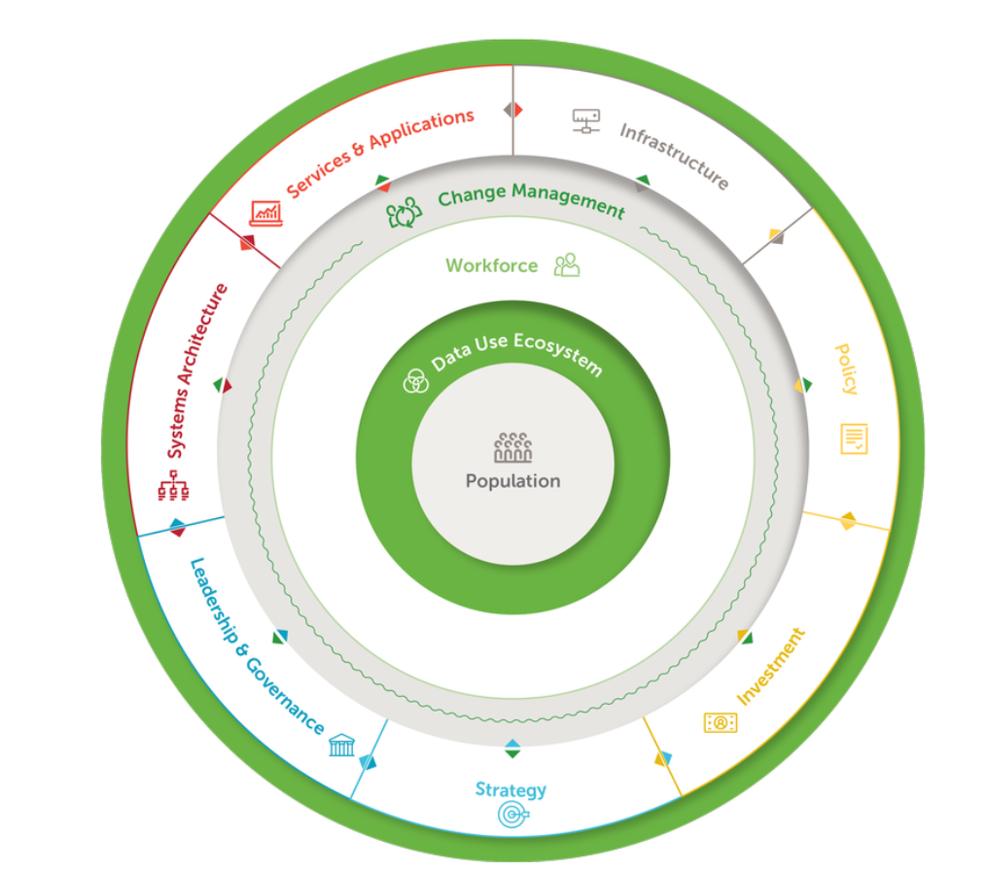
Figure 1. DUAL Model

Our model emphasizes our finding that all the core components enable and support one another in advancing digital transformation to improve data use. The digital transformation process is not a linear, step-by-step one and requires engaging diverse stakeholders, often through human-centered design approaches, to be successful. Specifcially, DUAL recommends the following actions that stakeholders can take to improve their digital transformation efforts related to stakeholder engagement:

- To engage stakeholders and improve leadership:
  - country governments can form technical working groups across sectors; and
  - country governments can cultivate digital health champions at all levels of the health system.

Did DUAL identify any lessons around replicability?
Yes, the DUAL model builds on the direct experiences and lessons learned from countries going through their digital transformation process in the hope that they can be applied in other countries and reflected in future digital transformation investments and policies. DUAL identified enabling factors, tools, and approaches that can be used to support countries and their implementing partners in developing and advancing their digital transformation models. Additionally, the model identifies ten digital transformation elements against which key factors of success for each element are detailed. The model also recommends specific practical actions for countries.

Other frameworks
Did DUAL consider research and development?
The DUAL model takes a holistic view of digital transformation and identified 10 essential elements of sustainable digital transformation based on the direct experiences and lessons learned from five countries in Sub-Saharan Africa These elements include considerations for the technical design and development of digital systems and tools, in addition to other factors such as infrastructure, the health workforce, and the policy environment.

What is the added value of DUAL model?
The DUAL model identifies ten digital transformation elements —governance and leadership, strategy, investment, systems architecture, services and applications, health workforce, policy and standards, digital health infrastructure, data use ecosystem, and change management – adding two new components to the WHO-ITU eHealth Strategy building blocks: change management and data use ecosystems. The model distills the key factors of success for each element and recommends specific practical actions for countries in advancing digital transformation for data use. The DUAL model also provides calls to action for key stakeholder groups to help advance these important digital transformation efforts.

What other frameworks or models did DUAL consider?
The DUAL model evolves the WHO-ITU eHealth Strategy building blocks. Other key resources DUAL reviewed and considered include: WHO’s Digital Investment Implementation Guide, Asian Development Bank’s Digital Health Impact Framework, the Performance of Routine Information System Management learning framework, and several change management models..

Socialization of the model
Where will the DUAL model be presented?
The DUAL model will be presented at several conferences, as well as regional and global meetings. For more information on conference presentations including exact dates and times please view our events calendar.

